Why Do the Seasons Change? Worksheet

Use the basic picture below to model how Earth’s tilt, rotation, and orbit influence the seasons we experience on Earth. Use labels, symbols, arrows, and other creative ways to support your visual representation.

Your representation must include:
- The direction of Earth’s orbit
- An indication of the direction of Earth’s tilt at various points in its orbit
- The typical seasons in the Northern and Southern Hemisphere throughout Earth’s orbit
- The summer and winter solstices
- The spring and autumn equinoxes

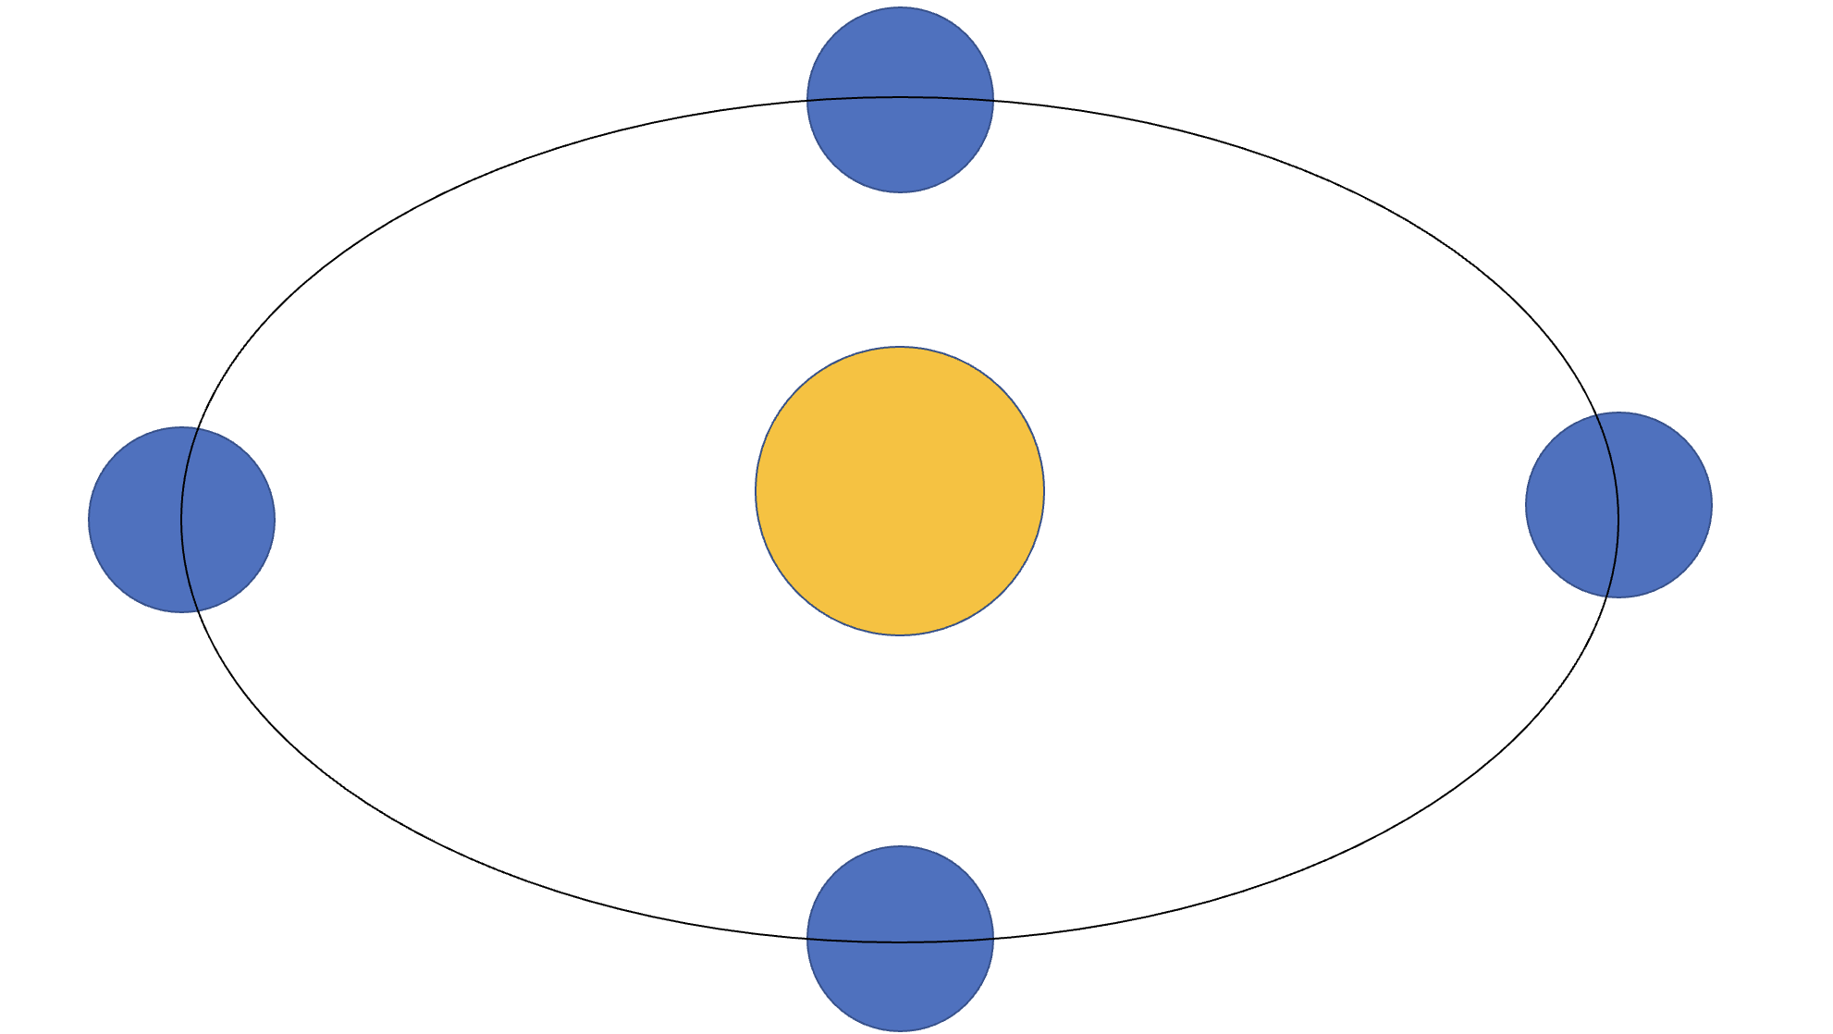

Use your model to help you answer the following questions:

- Why do the Northern Hemisphere and Southern Hemisphere experience the opposite seasons at the same time?

- What does the March equinox represent in the Northern Hemisphere? What does it represent in the Southern Hemisphere?

- What does the December solstice represent in the Northern Hemisphere? What does it represent in the Southern Hemisphere?

- Why do temperatures seem to be more extreme in the winter and summer than in the spring and autumn?

Challenge 1: What do you notice about the equator and its proximity (nearness) to the sun during any stage of Earth’s orbit? How does this influence the seasons in areas around the equator?

Challenge 2: Based on what you know about daylight hours near the equator, explain why the North and South Pole experience six months of near-continuous darkness followed by six months of near-continuous sunlight.

